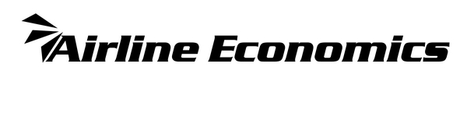
Airline Economics
Global Leaders Aviation 100 Awards 2023
Aviation Finance & Leasing Technology Award 2023
NOMINATION ENTRY FORM

Aviation 100 Aviation Finance & Leasing Technology Award 2023
This is a new award category open for nominations from companies that have launched data technology platforms/systems specifically for the aviation finance & leasing industry during 2022.
The past few years have witnessed the development of a wealth of new systems to aid the aviation industry, whether is counting carbon emissions, or tracking asset values or restructuring processes. With this in mind, we would like you to nominate the company and system, launched in 2022, which you believe is worthy of recognition for an Airline Economics Aviation 100 Awards for 2023.

Please submit one nomination for your product using the form below (if you are submitting multiple products for consideration, please use a separate form for each) and return it to Victoria Tozer-Pennington victoria@aviationnews-online.com with the subject line: AE Aviation 100 Tech Award 2023 by 24th December 2022.

ENTRANTS CONTACT INFORMATION
Company name:
Main contact for this nomination:
E‐mail address:
Telephone:

NOMINATION DETAILS
Award category: Aviation Finance & Leasing Technology Award 2023
Deal name:
Product name:
Companies and/or individuals involved and their roles in the development process:
Other companies and clients involved and their roles:
Country/region of company:
Product launch date:
Website illustrating the innovation: (if no live website, please attached any supporting documentation that best describes the product)

Detailed Summary of Your/Nominee's Innovation: (please be detailed and specific regarding the development of the product, how it works, how it answers an industry need, what makes it innovative in the aviation finance & leasing industry, success stories since its launch/implementation, essentially why your product is deserving of recognition.

Client endorsement / case stories?
If you are able, please also attach with your nomination two endorsements from clients who are familiar with and/or are currently using the product. Ideally these should be attached with this form, but they may be sent separately.

